2021 – EYNESBURY TO EXFORD PS – beginning 29 Jan 2021

BUS ONE - MORNING ROUTE: DRIVER: TBA
Bus One | 8:25 am  8:30 am  8:35 am  8:45 am | Depart – Cnr Eynesbury Road & Charlton Avenue  Depart – Cnr Eynesbury Road & Marong Avenue  Depart – Kyneton Avenue (Park Reserve)  Arrive - Exford Primary School | 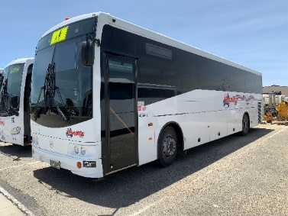  Swan Hill Coaches (Bus Biz)
BUS ONE – AFTERNOON ROUTE: DRIVER: TBA
Bus One | 3:30 pm  3:35 pm  3:45 pm  3:50 pm  3:55 pm | Arrive - Exford Primary School  Depart - Exford Primary School  Arrive – Cnr Eynesbury Road & Charlton Avenue  Arrive – Cnr Eynesbury Road & Marong Avenue  Arrive – Kyneton Avenue | 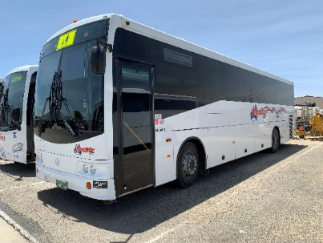  Swan Hill Coaches (Bus Biz)

BUS TWO - MORNING ROUTE: DRIVER: TBA
Bus Two | 8:20 am  8:30 am  8:35 am  8:45 am | Depart – Pro Shop  Depart - Bendigo Drive (corner Bendigo Drive & Rushworth Avenue at 10th Green)  Depart -62 Rushworth Avenue  Arrive - Exford Primary School | 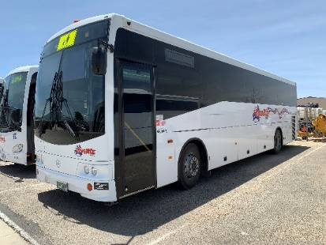  Swan Hill Coaches (Bus Biz)
BUS TWO – AFTERNOON ROUTE: DRIVER: TBA
Bus Two | 3:30 pm  3:35 pm  3:45 pm  3:50 pm  3.55 pm | Arrive at Exford Primary School  Depart Exford Primary School  Arrive – Pro Shop  Arrive - Bendigo Drive (corner Bendigo Drive & Rushworth Avenue at 10th Green)  Arrive – 62 Rushworth Avenue | 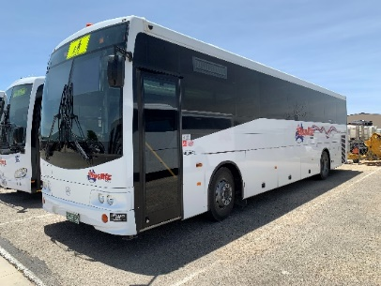  Swan Hill Coaches (Bus Biz)

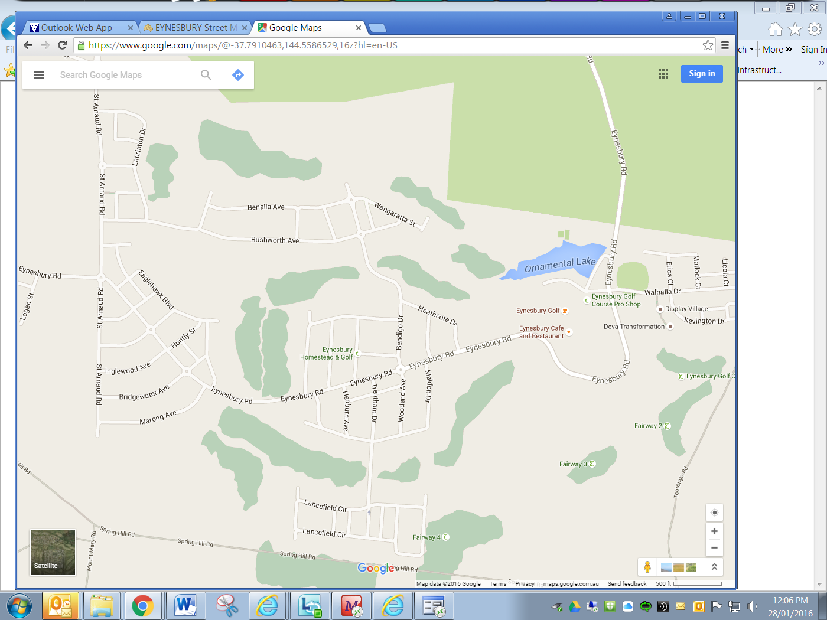 | BUS ONE  8:25 am – Corner Eynesbury Road & Charlton Avenue  8.30 am - Corner Eynesbury Road & Marong Avenue  8.35 am - Kyneton Avenue (Park reserve)  BUS TWO  8:20 am – Pro Shop  8.30 - Cnr Bendigo and Rushworth (10th green)  8.35 am - 62 Rushworth Ave

